

***Interim semester 2024-2025***

**Course code: CHI1002**

**Course Title:  Security and Privacy Policies for Health Care**

**Submitted by:**

**Neha Kohli**

**22BHI10052**

**Submitted to : Dr Swagat Kumar Samantaray**

**Date: 20.11.2024**

**KEYLOGGERS: APPLICATIONS IN HEALTHCARE SECTOR**

**IMPLEMENTATION AND DEMO:**

Source code: <https://drive.google.com/file/d/1bVzamCkMstXvtKQFBZLI6ejXsCor8RjU/view?usp=sharing>

Demo: <https://drive.google.com/file/d/1SraEM5LPoSQmnBLNz_MCl-vc2W9LcMCD/view?usp=sharing>

**INTRODUCTION**

Keyloggers are tools designed to track and record keystrokes, with a history dating back to the 1980s. Initially utilized by intelligence agencies, they are now widely accessible in both software and hardware forms. Keyloggers serve various applications, from cybersecurity and performance monitoring to user behavior analysis.

While often associated with malicious activities—such as data theft and unauthorized surveillance—they can also provide significant benefits when used ethically, particularly in sensitive sectors like healthcare. In these contexts, keyloggers can help monitor user interactions with systems, identify errors, and enhance training programs.

**Keylogger Types**

1. **Hardware Keyloggers**

* **Description**: Physical devices connected between a keyboard and a computer.
* **Functionality**: Capture keystrokes without software, undetectable by antivirus.
* **Limitations**: Cannot log mouse clicks or screenshots; require physical access.

1. **Software Keyloggers**

* **Description**: Programs installed on a computer.
* **Functionality**: Run in the background, evading antivirus detection.
* **Features**: Include clipboard logging, screen capture, and web tracking.

**INSTALLATION INSTRUCTIONS**

To install and run the keylogger:

1. **Download the Python File**: Download the keylogger.py script from the link provided.
2. **Install Required Library**: Open a command prompt or terminal and run: ***pip install pynput***
3. **Run the Keylogger**: Navigate to the directory of keylogger.py and execute:

***python keylogger.py***

1. **Stop Logging**: Press the Escape key to stop the keylogger.

**WORKING OF KEYLOGGER:**

***Components include:***

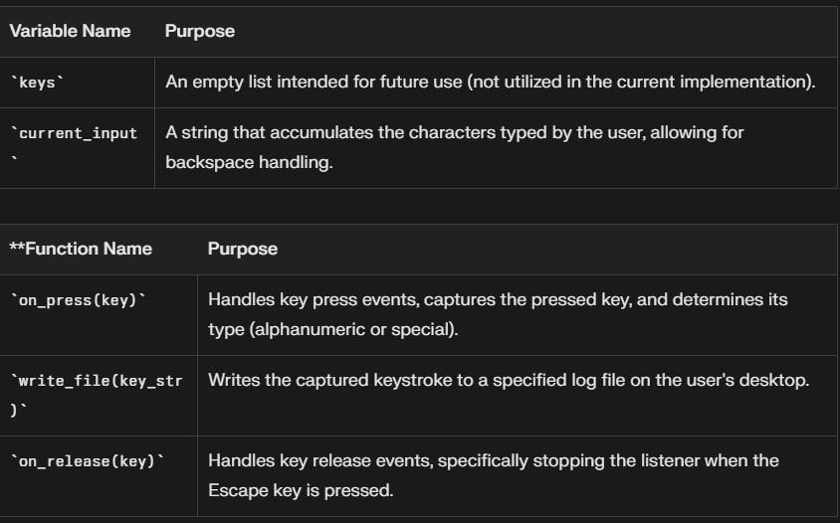

***Workflow:***



1. **Initialization**:
   * The keylogger starts by importing necessary libraries from **pynput**, which are essential for capturing keyboard events. It initializes two global variables: **keys**, which is an empty list for potential future use, and **current_input**, a string that will store all typed characters.
   * When the user runs the keylogger script, they may not see any visible changes, but the program is preparing itself to monitor their keyboard activity.
2. **Key Press Event Handling**:
   * The core functionality of the keylogger is encapsulated in the **on_press** function. This function is triggered each time a key is pressed. It initializes a variable to hold the string representation of the pressed key.
   * The function attempts to capture whether the pressed key is alphanumeric or a special key (like space, enter, or backspace). If it’s an alphanumeric character, it is added to **key_str**. For special keys, specific actions are defined:
     + Space is recorded as a space character.
     + Enter creates a newline.
     + Backspace removes the last character **from current_input** and logs this action as **[BACKSPACE].**

As the user types on their keyboard, each keystroke is detected by the keylogger. They may notice no interruption in their typing experience, but every character they input is being recorded.

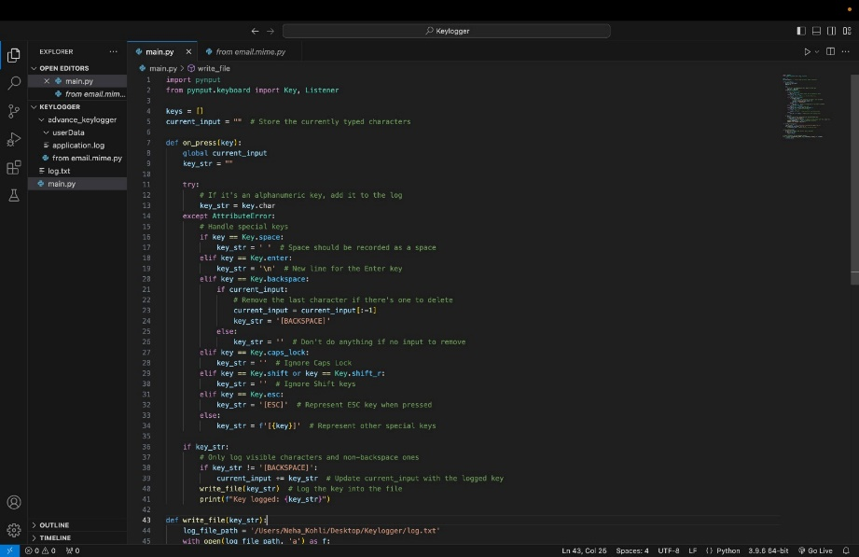

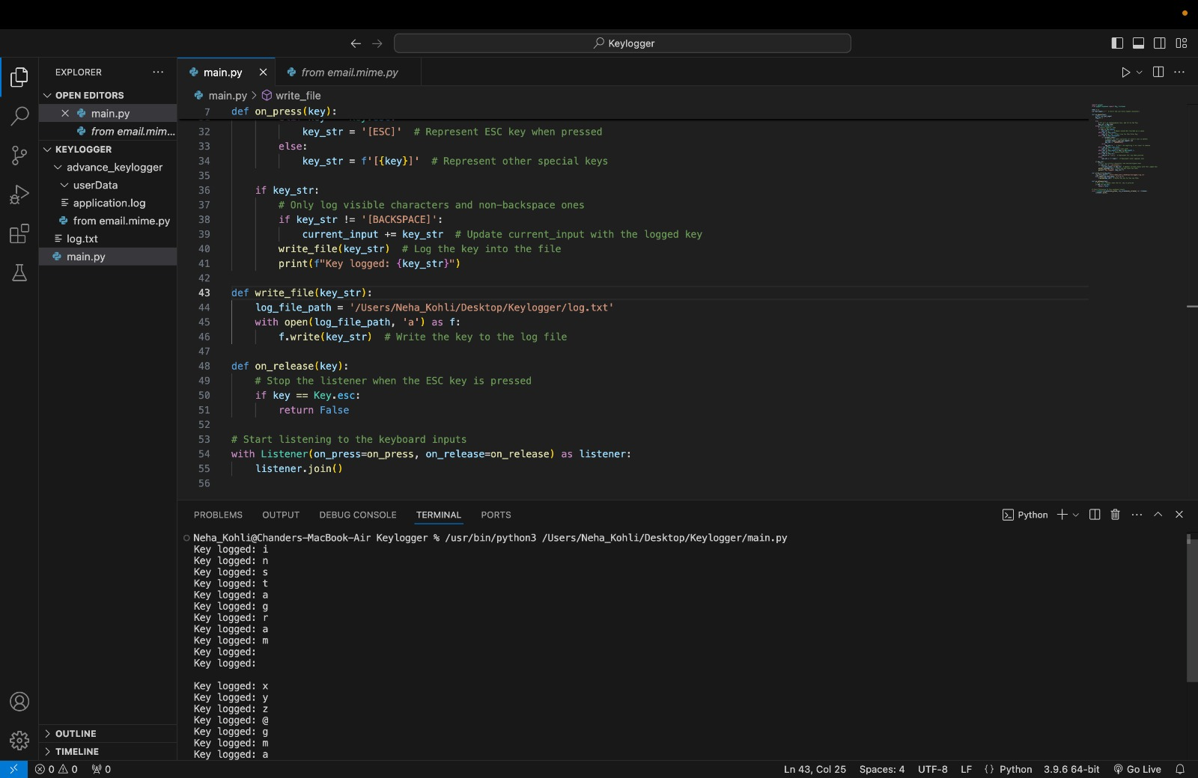

1. **Logging Keystrokes**:
   * If key_str contains a valid value (not empty or just Backspace), it gets appended to current_input. The program then calls write_file(), which writes this keystroke to a log file on the user's desktop.
   * The logged key is also printed to the console for real-time feedback, allowing users to see what keys are being captured.

While typing, users can glance at the console (if they have it open) and see their keystrokes being logged in real-time. They might not realize that every keystroke is being saved in a file on their desktop.

1. **Key Release Event Handling**:
   * The on_release function monitors when keys are released. If the Escape key is detected as pressed, this function stops the listener and effectively ends the keylogging session.
2. **Starting the Listener**:
   * An instance of Listener is created, linking it to both the on_press and on_release functions. This listener runs continuously in an infinite loop until it detects that the Escape key has been pressed.

Users may not be aware of this continuous listening process; they simply type as usual, while the listener remains active in the background.

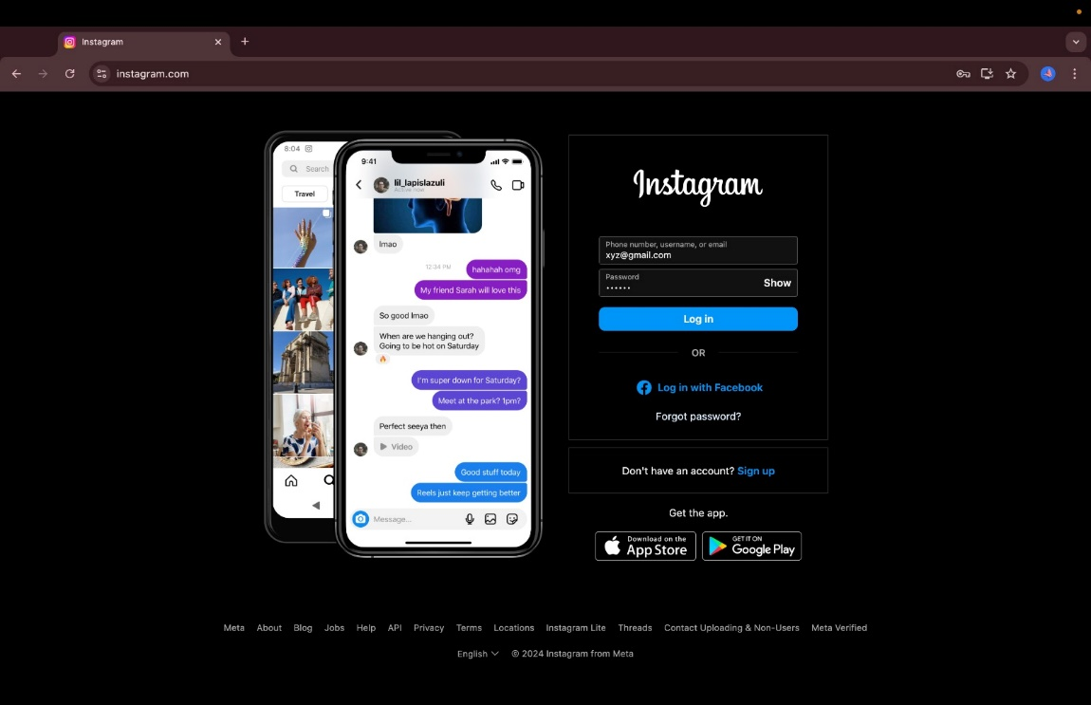

1. **File Writing Functionality**:
   * The write_file() function handles writing captured keystrokes to a specified log file. It opens this file in append mode, ensuring that new entries are added without overwriting existing data.
   * This functionality ensures that all keystrokes are preserved for future analysis or review.

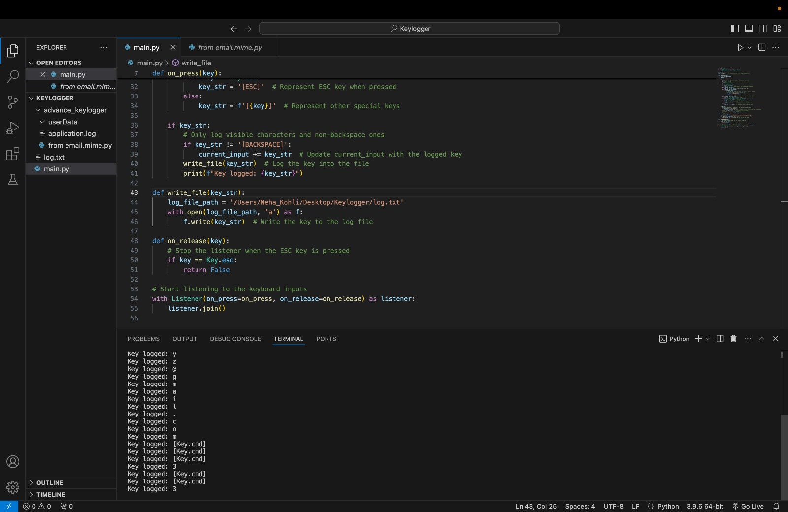

**APPLICATIONS OF KEYLOGGERS IN HEALTHCARE**

1. **Error Detection and Monitoring**:  
   Keyloggers identify typos and inconsistencies in Electronic Health Records (EHRs), leading to a **40% reduction in medication entry errors** through real-time feedback.
2. **Staff Training and Performance Assessment**:  
   By tracking typing speed and accuracy, keyloggers enhance staff performance, resulting in a **30% improvement in system efficiency** for new employees adapting to healthcare software.
3. **System Performance Optimization**:  
   Keyloggers reveal underused EHR features, helping to streamline data entry processes and increase clinician efficiency by **25%**.
4. **Research and Clinical Applications**:  
   They aid in data collection during clinical trials, optimizing patient questionnaires and achieving a **20% reduction in completion time** through refined interfaces.
5. **Enhancing Security and Compliance**:  
   Keyloggers support auditing for HIPAA compliance and detect unauthorized access, preventing potential data breaches by monitoring suspicious keystroke patterns.

**FUTURE SCOPE**

As we enhance our keylogger project, several advanced features can significantly improve its functionality and utility in monitoring and security applications. Here’s a focused look at the exciting possibilities ahead:

### **1. Comprehensive System Information Gathering**

By expanding our data collection capabilities, we can log essential system metrics alongside keystrokes. This includes:

* **Processor Information:** Capture details about the CPU to assess performance.
* **Operating System Details:** Record the OS version for compatibility checks.
* **Network Information:** Gather both private and public IP addresses for security audits.

*public_ip = get("https://api.ipify.org").text*

### **2. Contextual Screenshots**

Integrating screenshot functionality allows us to capture the screen at critical moments, providing visual context to logged keystrokes. This can be particularly useful for:

* **Error Monitoring:** Automatically take screenshots when specific keywords are typed (e.g., "error" or "fail").

*im = ImageGrab.grab()*

*im.save(os.path.join(file_path, screenshot_information))*

### **3. Webcam Photo Capture**

Adding webcam integration enables us to capture images of users during their interactions with the system. This feature can enhance security by:

* **User Verification:** Taking a photo when sensitive actions are performed, ensuring that only authorized personnel are accessing critical information.

cap = cv2.VideoCapture(0)

### **4. Automated Data Cleanup**

The collected data, including logs, screenshots, and webcam images, will be sent to the designated email address (your_gmail) via SMTP, ensuring secure transmission of sensitive information.

To uphold user privacy and data security, implementing an automated cleanup process is essential. After sending logs and screenshots via email, we can ensure that sensitive files are deleted from local storage.

*os.remove(os.path.join(file_path, file))*

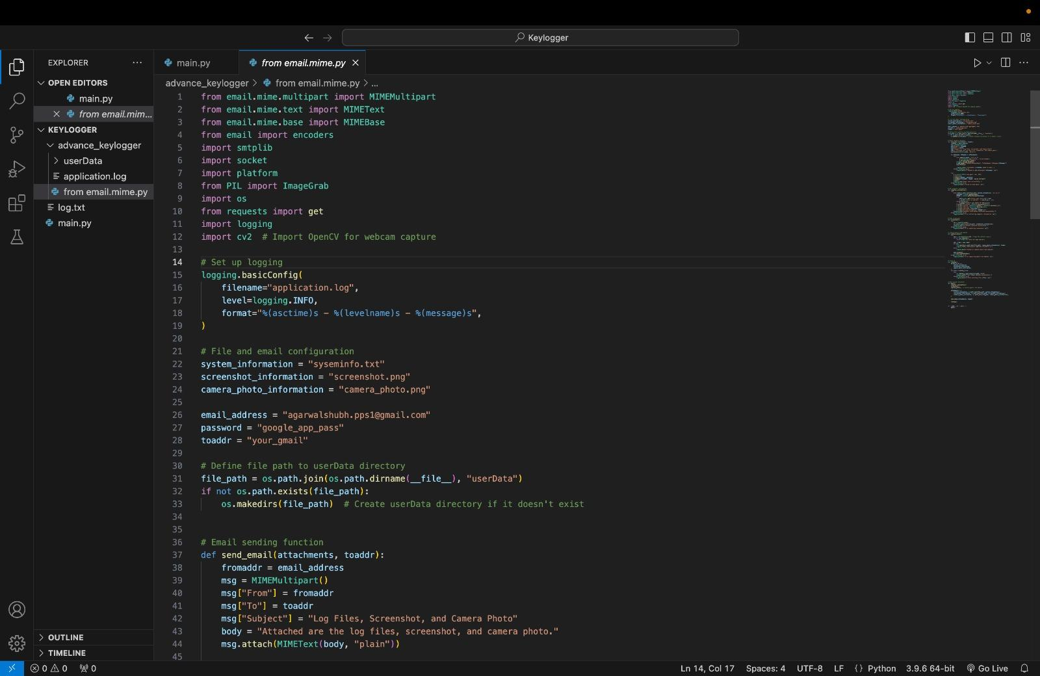

### **5. Real-Time Alerts and Notifications**

Integrating real-time alerts based on specific triggers can enhance proactive monitoring capabilities. For instance:

* **Keyword Detection:** Set up alerts for suspicious phrases or actions that may indicate unauthorized access or potential breaches

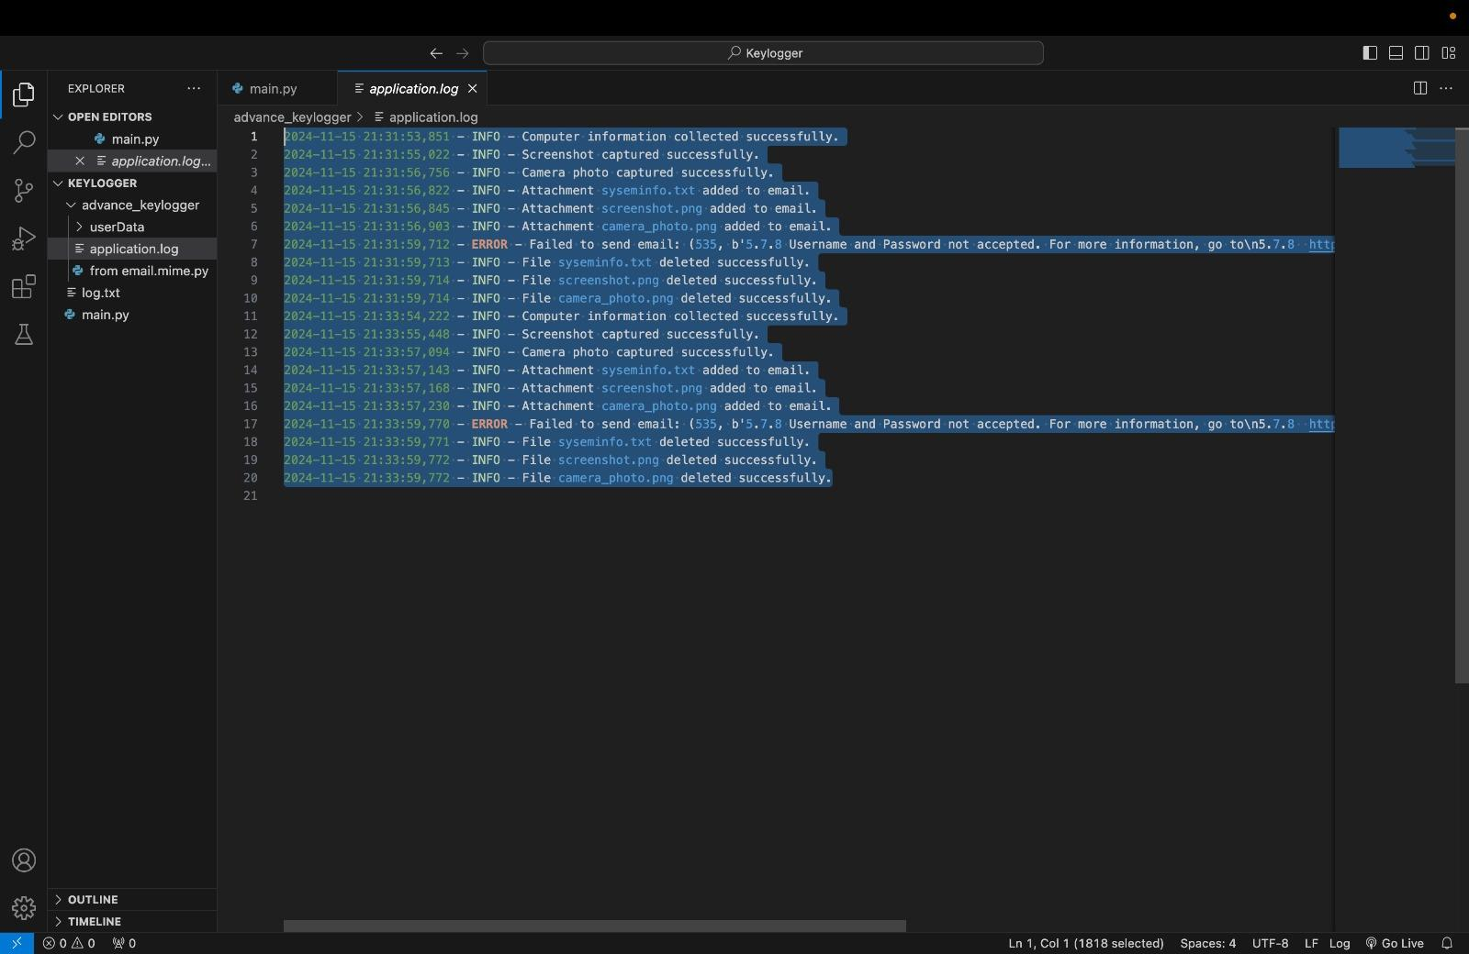

**ETHICAL AND PRIVACY CONSIDERATIONS**

While keyloggers offer numerous benefits, ethical implementation is critical to maintain trust and privacy:

* **Informed Consent**: Users must be aware of and consent to keylogger use.
* **Privacy Safeguards**: Systems should exclude sensitive patient information from logging.
* **Regulatory Compliance**: Adherence to laws like HIPAA in the US and GDPR in the EU is essential.
* **Transparency**: Clear communication about keylogging purposes builds trust and mitigates concerns.

**CONCLUSION**

Keyloggers, when deployed responsibly, offer transformative potential in healthcare and other industries. Their ability to enhance data accuracy, optimize workflows, and bolster security makes them invaluable tools. However, ethical practices and robust safeguards must govern their use to balance innovation with privacy. By leveraging keyloggers effectively, institutions can drive efficiency, minimize errors, and ultimately improve outcomes.

**DEMO**

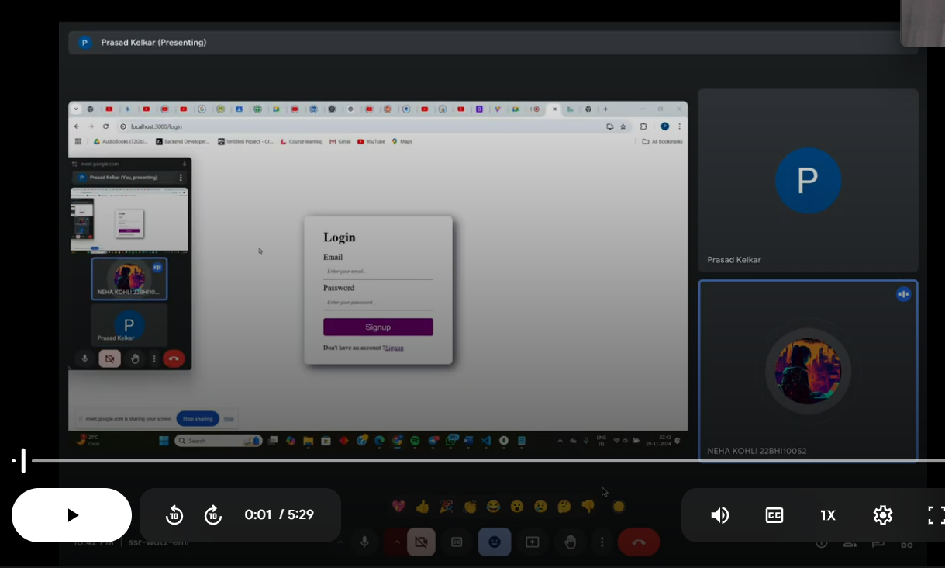

<https://drive.google.com/file/d/1SraEM5LPoSQmnBLNz_MCl-vc2W9LcMCD/view?usp=sharing>